Name : Hardik Patel
Std Id : 202103032

Q.1 Write the code for the following problems through Recursion:
a. Reverse the linked list through the recursion.
b. Find Fibonacci series of length n
c. Count the sum of the digits of a given numb

Code :

package com.DSA.LAB8;

public class LL {

private Node head;
private Node tail;
private int size;

public LL() {
this.size = 0;
}

public void insertFirst(int val) {
Node node = new Node(val);
node.next = head;
head = node;
if (tail == null) {
tail = head;
}
size += 1;
}

public void insertLast(int val) {
if (tail == null) {
insertFirst(val);
return;
}
Node node = new Node(val);
tail.next = node;
tail = node;
size++;
}

public void insert(int val, int index) {

if (index == 0) {
insertFirst(val);
return;
}

if (index == size) {
insertLast(val);
return;
}

Node temp = head;
for (int i = 1; i < index; i++) {
temp = temp.next;
}

Node node = new Node(val, temp.next);
temp.next = node;

size++;
}

public void display() {
Node temp = head;
while (temp != null) {
System.out.print(temp.value + " -> ");
temp = temp.next;
}
System.out.println("END");
}

private class Node {
private int value;
private Node next;

public Node(int value) {
this.value = value;
}

public Node(int value, Node next) {
this.value = value;
this.next = next;
}
}

//a. recursion reverse in linked-list
private void reverse(Node node) {
if (node == tail) {
head = tail;
return;
}

reverse(node.next);

tail.next = node;
tail = node;
tail.next = null;
}

//b. Find Fibonacci series of length n
static int fib(int num)
{
// Base Case
if (num <= 1)
return num;
// Recursive call
return fib(num - 1) + fib(num - 2);
}

//c. Count the sum of the digits of a given number
static int findSum(int number) {
if(number == 0){
return number;
}
else{
return number % 10 + findSum(number / 10);
}
}

public static void main(String[] args) {
LL first = new LL();
first.insertLast(1);
first.insertLast(2);
first.insertLast(3);
first.insertLast(4);
first.insertLast(5);
System.out.println("List before Reverse : ");
first.display();

first.reverse(first.head);
System.out.println("List after Reverse : ");
first.display();
System.out.println();

int num = 5;
System.out.println("Fibonnaci series till " + num);

for (int i = 0; i < num; i++) {
System.out.print(fib(i) + " ");
}

System.out.println("\n");

int number = 1234;
System.out.println("The sum of digits "+ number + " = " + findSum(number));

}
}
Output :
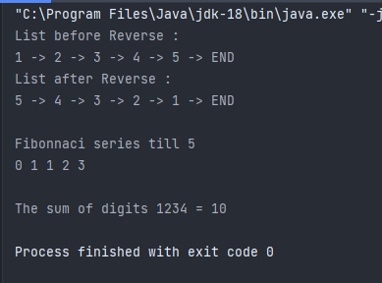

Q.2 Implement a stack using queues (only 2 queues). The implemented stack should support all the functions of a normal stack (push, top, pop, and empty)

Code :

package com.DSA.LAB8;

import java.util.LinkedList;
import java.util.Queue;

public class MyStack {

private Queue<Integer> q1 = new LinkedList<>();
private Queue<Integer> q2 = new LinkedList<>();
private int top; // for tracking top

public void push(int num){
q1.add(num); // simply push or add in queue
top = num; // track top(update)
}

public int pop(){
// iterate in q1 till reach last element
while (q1.size()>1){
top = q1.remove();
q2.add(top); //copy element of q1 in q2
}

int ans = q1.remove();

// swapping elements in both queues
Queue<Integer> temp = q2;
q2 = q1;
q1 = temp;

return ans;
}

public int top(){
while (q1.size()>1){
top = q1.remove();
q2.add(top);
}

int ans = q1.peek();

q1.remove();
q2.add(ans);

Queue<Integer> temp = q2;
q2 = q1;
q1 = temp;

return ans;
}

// check if Queue 1 is empty or not
public boolean empty(){
return q1.isEmpty();
}

public static void main(String[] args) {
MyStack stack = new MyStack();
stack.push(1);
stack.push(2);
stack.push(3);
stack.push(4);
stack.push(5);

System.out.println("pop = " + stack.pop());
System.out.println("pop = " + stack.pop());
System.out.println("pop = " + stack.pop());
System.out.println();

System.out.println("top = " + stack.top());
System.out.println();

System.out.println("pop = " + stack.pop());
System.out.println("pop = " + stack.pop());
System.out.println();

System.out.println("empty = " + stack.empty());
}
}
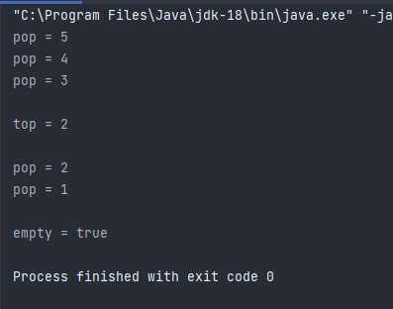
Output :

Q.3 Write function(s) to multiply each data of the stack with X and store the elements in a linked list (insert at head) as shown in figures bwlow.
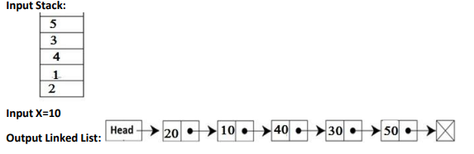

Code :

package com.DSA.LAB8;
import java.util.LinkedList;
import java.util.Scanner;
public class Multiply {
private Node head;
private Node tail;
private int size;
static class Node{
int data;
Node next;
Node(int data){
this.data = data;
next = null;
}
}
public void insertFirst(int data){
Node node = new Node(data);
node.next = head;
head = node;
if(tail == null){
tail = head;
}
size+=1;
}
public void display(){
Node temp = head;
while (temp != null){
System.out.print(temp.data + "->");
temp = temp.next;
}
System.out.println("END");
}
static class Stack{
private static Node head;
public static int size;
public static boolean isEmpty(){
return head == null;
}
public void push(int data){
Node node = new Node(data);
if(isEmpty()){
head = node;
}
node.next = head;
head = node;
size+=1;
}
public static int pop(){
if(isEmpty()){
return -1;
}
int top = head.data;
head = head.next;
size--;
return top;
}
public static int peek(){
if(isEmpty()){
return -1;
}
return head.data;
}
}
public static void main(String[] args) {
Scanner in = new Scanner(System.in);
Multiply list = new Multiply();
Stack stack = new Stack();
stack.push(2);
stack.push(1);
stack.push(4);
stack.push(3);
stack.push(5);
System.out.println("Enter the number you want to multiply :");
int n = in.nextInt();
int num;
while(stack.size>=1){
num = stack.pop()*n;
list.insertFirst(num);
}
list.display();
}
}
Output :
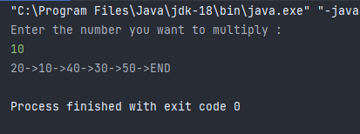

- For any mathematical equation to run successfully, the parenthesis plays a vital role in its solution. For long equations, there are the chances of the misplaced brackets or missing brackets. Being a futuristic potential engineer, design a parenthesis balance checking program. For eg.: [(A+B)-(C+D)} → Unbalanced [A+B(C+D(E+G)] → Unbalanced [A+{B+(C+D)+E}+F]

Code :

package com.DSA.LAB8;
import java.util.*;
public class CheckBalanced {
//check if brackets are balanced
static String checkBalanced(String str)
{
Stack<Character> stack = new Stack<>();
// Traversing the Expression
for (int i = 0; i < str.length(); i++)
{
char ch = str.charAt(i);
if (ch == '{' || ch == '(' || ch == '[')
{
// Push the element in the stack
stack.push(ch);
}
// brecket must be open if not close
if (stack.isEmpty()) {
return "Not Balanced";
}
char check;
switch (ch) {
case '}':
check = stack.pop();
if (check == '(' || check == '[') {
return "Not Balanced";
}
break;
case ']':
check = stack.pop();
if (check == '(' || check == '{') {
return "Not Balanced";
}
break;
case ')':
check = stack.pop();
if (check == '[' || check == '{') {
return "Not Balanced";
}
break;
}
}
// Check if Stack is emptyy
return "Balanced";
}
public static void main(String[] args)
{
String str1 = "[(A+B)-(C+D)}";
System.out.println(str1);
System.out.println(checkBalanced(str1));
System.out.println();
String str2 = "[A+B(C+D(E+G)]";
System.out.println(str2);
System.out.println(checkBalanced(str2));
System.out.println();
String str3 = "[A+{B+(C+D)+E}+F]";
System.out.println(str3);
System.out.println(checkBalanced(str3));
}
}
Output :
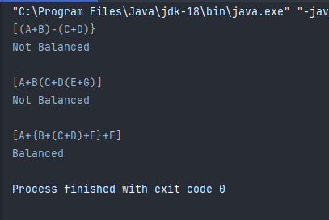

Q.5 Accept the evaluation formula string from user and evaluate the formula using stack.
For eg.: Input: (1+(2*3)-5)
Output: 2
Hint: You may use infix or postfix expression for the solution

Code :

package com.DSA.LAB8;
class Evaluate{
//check if a given character is operand
static boolean isOperand(char c)
{
return (c >= '0' && c <= '9');
}
// find value of and operand
static int value(char c)
{
return (int)(c - '0');
}
//evaluates simple expressions.
static int evaluate(String str)
{
// Base Case: Given expression is empty
if (str.length() == 0){
return -1;
}
//find First operand value
int val = value(str.charAt(0));
// Traverse the remaining characters in pairs
for (int i = 1; i<str.length(); i += 2)
{
// on even position must be : operand
// and on odd must : operator
char opr = str.charAt(i), opd = str.charAt(i+1);
// If next to next character is not an operand
if (isOperand(opd) == false){
return -1;
}
// Update result according to the operator
if (opr == '+'){
val += value(opd);
}
else if (opr == '-'){
val -= value(opd);
}
else if (opr == '*'){
val *= value(opd);
}
else if (opr == '/'){
val /= value(opd);
}
// If not a valid operator
else {
return -1;
}
}
return val;
}
public static void main(String[] args)
{
String str1 = "3-2*3+1";
int val = evaluate(str1);
if(val == -1){
System.out.println(str1 + " is Invalid");
}
else {
System.out.println("Value of "+str1+" is "+val);
}
String str2 = "1-2*3+5";
val = evaluate(str2);
if(val == -1){
System.out.println(str2+" is Invalid");
}
else{
System.out.println("Value of " + str2+" is "+val);
}
}
}

Output :
